**Ansible Controller Organization**

**01-03-2022**

Ansible Docs - Organizations

<https://docs.ansible.com/automation-controller/latest/html/userguide/organizations.html>

1. You can create a new organization by clicking the **Add** button.

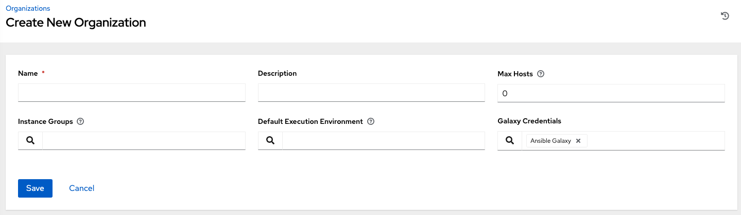

1. An organization has several attributes that may be configured:

* Enter the **Name** for your organization (required).
* Enter a **Description** for the organization.
* The **Max Hosts** is only editable by a superuser to set an upper limit on the number of license hosts that an organization can have. Setting this value to **0** signifies no limit. If you try to add a host to an organization that has reached or exceeded its cap on hosts, an error message displays:
* Enter **Instance Groups** on which to run this organization.
* Enter the name of the execution environment or search for an existing **Default Execution Environment** on which to run this organization. See [Upgrading to Execution Environments](http://docs.ansible.com/automation-controller/4.3/html/upgrade-migration-guide/upgrade_to_ees.html#upgrade-venv) in the *Ansible Automation Platform Upgrade and Migration Guide* for more information.
* If used, enter the **Galaxy Credentials** or search from a list of existing ones.
* Click **Save** to finish creating the organization.

**Access Users and Teams**

In order to add a user or team to an organization, the user or team must already be created. See [Create a User](https://docs.ansible.com/automation-controller/latest/html/userguide/users.html#ug-users-create) and [Create a Team](https://docs.ansible.com/automation-controller/latest/html/userguide/teams.html#ug-team-create) for additional detail. To add existing users or team to the Organization:

1. In the Access tab, click the Add button.
2. Select a user or team to add and click Next
3. Select one or more users or teams from the list by clicking the check box(es) next to the name(s) to add them as members and click Next.

In this example, two users have been selected to be added.

1. Select the role(s) you want the selected user(s) or team(s) to have. Be sure to scroll down for a complete list of roles. Different resources have different options available.

